A. Installing SyncroSim

Important information to note before installing SyncroSim.
- To install SyncroSim, you typically go to https://syncrosim.com/ and download it from there. However, SyncroSim evolves constantly and as a result, the screen or the version of the software at the time of your installation might be different from what we show in Figure 2 below.
- Additionally, one of the things that you will do at the start of your modeling activity is to call in a file called a Library, on which you will do the modeling activity (slide # 5 in supplemental material 3). If this library file was developed under one version of SyncroSim (e.g., 2.4.40), and the SyncroSim platform that you downloaded is a different version (e.g., 2.5.00), you are likely to experience a mismatch, such that the library file may not upload correctly onto that version of SyncroSim.
- Typically, there will be an opportunity to upgrade the library file at the time that you are bringing it into SyncroSim (updating on the fly), so that it can match whatever version of SyncroSim you installed. Occasionally, however, the user may experience problems where the updating is unsuccessful or gets stuck at a particular step of the updating process.
- To minimize this, we highly recommend that you download and use the version of SyncroSim that matches the one that the library file was made with.
- We developed this activity using an earlier version of SyncroSim, Version 2.4.40. To address the mismatch issue discussed above, we recommend that instead of following the typical link given above, you instead use the link https://syncrosim.com/past-versions/, that takes you to a list of previous versions. On this list, click the link for version 2.4.40 and download that version to use for this activity.
- This list of past versions of SyncroSim allows you to download and use whatever version works for you. We will also be updating this installation guide for new SyncroSim versions, and provide new library files that work with those versions. Everything will be available and can be downloaded on the website https://thenatureconservancy.github.io/landfiremodels/educators.html
- It is also our experience that when installing SyncroSim, it might be helpful to use the Stable version rather than the Beta version, if both are given at the time of your installation.

How to Install SyncroSim (Specific to this activity).
- Go to https://syncrosim.com/past-versions/, which takes you to a list of previous versions of SyncroSim.
- On this list, click the link for version 2.4.40 and download that version for this activity.
- If you get a message about your Microsoft defender preventing this app from installing just click the “more info” tab below the message and it should give you an option to install it. If you get another screen with a warning, just click the “run this program anyway” option
- You may be required to create an account as part of the installation process (when installing it for the first time). Follow the instruction given there to create an account and remember the username and password used.
- To open it after the initial installation, go to your windows icon and search for it among your apps.
  - Typically, there is only one version installed, but sometimes, you may see two versions when opening it. If so, open the “New” version, not the “lite” one.
  - If you open SyncroSim at a later time after the initial installation and use, you may be required to activate the software with a license. The license will be given on the screen, with instructions on how to accomplish this.
- The first time you open SyncroSim, you may get a screen like the one below (Fig 1), that says that a certain package needs to be installed before it can run. If you get this, just click ok.

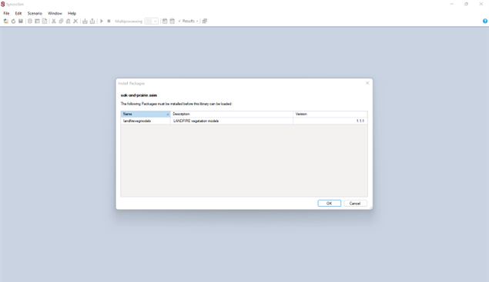
Fig 1. Screen image asking you to accept package installation

- When the installation is successful, your SyncroSim screen should look as follows (Fig 2). It is ready to go.
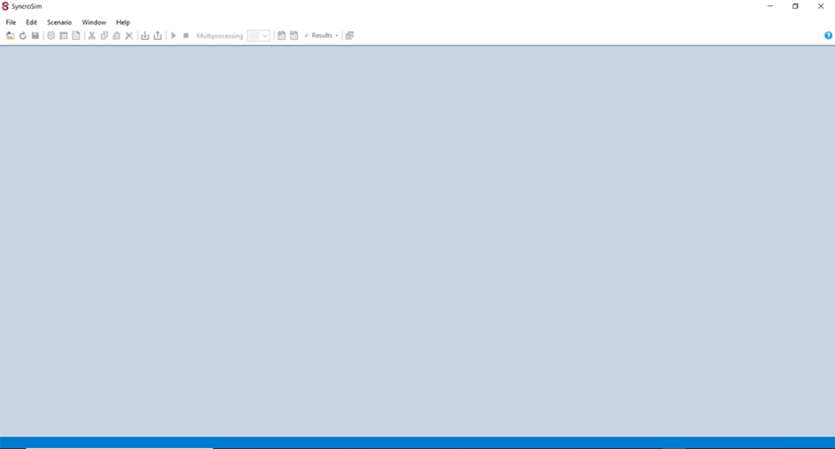
Fig. 2: How the SyncroSim platform should look when it is opened after a successful installation
.

B. Installing/Updating required packages for SyncroSim to work
- Once you install SyncroSim, we highly recommend that you check to ensure that the software has all of the critical updates and base packages to minimize running into problems once you start work.
- To do that, take the following steps to ensure that two critical base packages that you will need are installed and ready to go.
  - The two critical packages that you need to make sure are updated are:
    - landfirevegmodels
    - stsim

How to update the two required packages
- Open SyncroSim to have the screen as in Fig 2 above.
- Click File, then in the resulting box, click Packages (third option from the bottom). A packages window will pop up.
  - If the above two items (landfirevegmodels and stsim) are installed and ready to go, they should show up in the packages window, as seen in Fig 3 below.
  - If this is the case, then you can exit this packages window. It just means you do not have to update anything because these two packages are good to go.
  - However, if none of those two packages show up, or if only one of the two shows up, it means that you need to do some updating to install both of them (if both are missing in the list) or install the one that is missing (if only one is missing in the list).

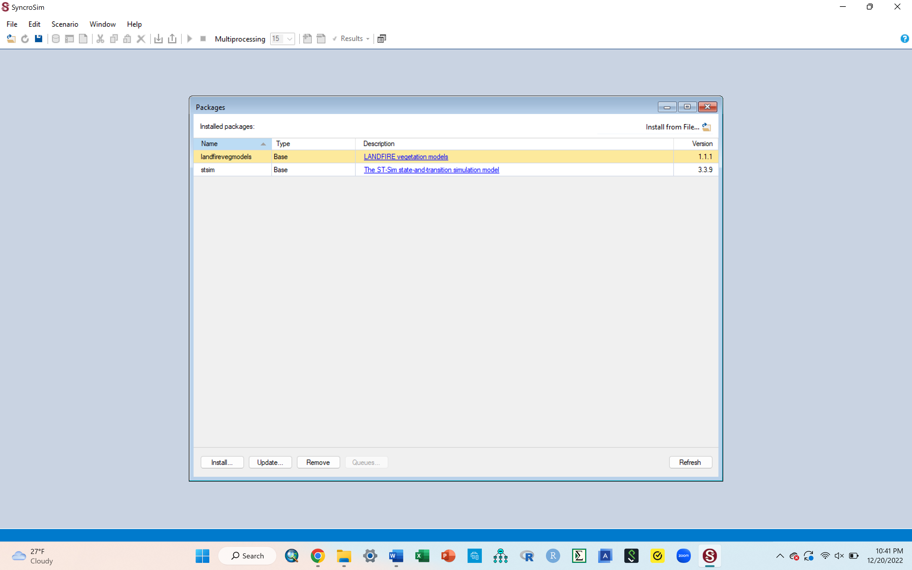
Fig.3. The two critical packages that should show up in packages list

- To update missing packages, click the Install tab that is at the bottom left corner of the Packages window (circled in green in Fig 4 below).
- A list of packages will appear, as shown in the in-set window in Fig 4 below.
- Put a check mark in the box next to both landfirevegmodels and the stsim packages in that list (if both were missing) OR put a check mark in the box next to whichever one was missing (if only one was missing).
- When done checking the boxes, click OK. Your packages should get updated immediately and you should be all set. Exit the Packages window.
- Just to be sure, you can click file, then packages, and check to see that the two packages show up, just like in Fig 3 above. We highly recommend you do this so that you are sure you have all you need, going into the activity.

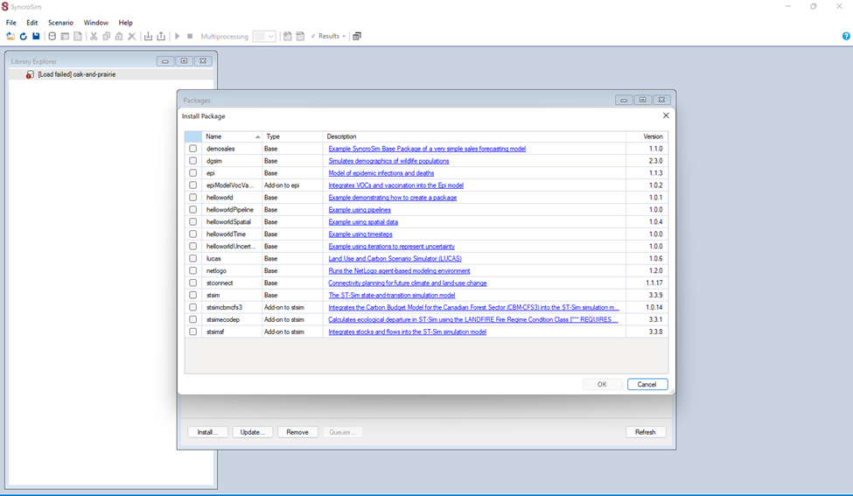
Fig 4. List of all packages from which to select the base packages that will be needed

